Summer Camp Counselor 2023
Explore and Expand Your
Personal Gifts and Talents
Seeking gifted and talented High School Juniors and Seniors
Flint Hill Farm Educational Center offers children from the Greater Lehigh Area the opportunity to have a hands-on "ON THE FARM:" summer experience.
MAKE A DIFFERENCE IN CHILDREN'S LIVES - AGES 2-3, 4-6 AND 7-13
CHOOSE YOUR OWN FIELD OF INTEREST
MOMMY, DADDY AND ME AGES 2-3
KINDERCAMP AGES 4-6
FARM CAMP AND HORSELOVERS CAMP AGES 7-13
​
Great opportunity for students looking into the following fields:
AG-ED , pre-school or elementary education, special ed, physical fittness, forestry, animal science, gardening, soil science, dairy, conservation.

BASIC REQUIREMENTS:​
​1 MUST BE JUNIOR OR SENIOR IN HS - 17 OR OLDER
2. HAVE RELIABLE TRANSPORTATION
3. CELL PHONE
4. ENJOY TEACHING CHILDREN 4-13 YR OLD
5. AVAILABLE END OF JUNE - AUGUST. HAVE SUMMER VACATION TRIPS SCHEDULED PRIOR TO JUNE 19 OR AFTER AUGUST 11
6. ABLE TO PRESENT 2 CHARACTER REFERENCES
7. COMPLETE CHILD ABUSE SCREENING
8. COMPLETE CAREERLINK APPLICATION IF LIVING IN LEHIGH OR NORTHAMPTON COUNTY FOR SUMMER JOB
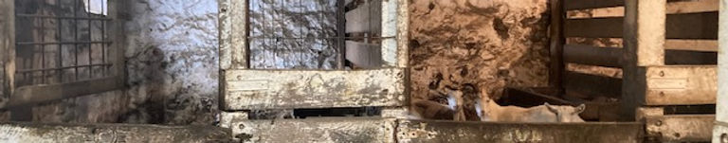
Contact Flint Hill Farm Educational Center, Inc. 1922 Flint Hill Road, Coopersburg, PA 18036
www.flinthillfarm-edcenter.org 610-838-2928 Kathleen Fields president and farmer

